The following regression equation have found on Wooldridge text book (This data set more used in Wooldridge, pages: 166-167, 341-342).
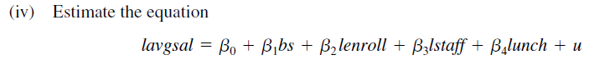

Explaining the theory behind my model
I haven’t found any dummy variable in my dataset. Therefore, I had to make my model without dummy variable. My regression model looks as follows:
$$\hat{lavgsal}= β_{0} + β_{1}bs+β_{2}lenroll+ β_{3}lstaff+β_{4}lunch+ \hat{u}$$
In this model,
Dependent variable
- lavgsal: log (average teacher salary, $)
Independent variables
- bs: average benefit / average salary
- lenroll: log(enrollment)
- lstaff: log (staff per 1000 students)
- lunch: percent eligible, free lunch
In this model, I am going to estimate the linear relationship of percentage of average teacher salary, which is dependent on bs, lenroll, lstaff, lunch by using OLS method. If the value of the independent variable changes, how much the average teacher wage changes. For example, how much average teacher salary changes if student enrollment increases?

Determining the functional form

Assumption 9 of the classical linear regression model (CLRM) states that the analysis's regression model should be "correctly" specified. The issue of model specification error or model specification bias arises if the model is not "correctly" specified. It could have happened for a number of reasons.
There are multiple ways to test the specification errors. Here, to determine the functional form, I am going to use Ramsey Reset test.
Assignment 16: Ramsey Reset test
Obtaining the estimated value of lavgsal, as yhat from the choosen regression model
After generating the value of yhat_2, yhat_3, yhat_4 in some form as an additional regressors. Then we rerun the regression as follows
Obtained R2 from both equation and calculating F value by applying the following formula:
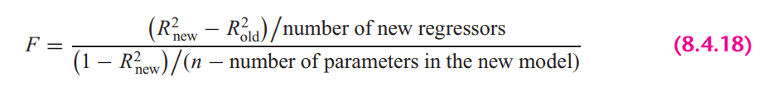
In STATA, the calculation looks as follows:

Rule: If the computed F value is significant, at the 5 percent level, one can accept the hypothesis that the model is mis-specified.
Findings: From the results we can see that, F value is insignificant at 5% percent significance level, therefore, we can reject the hypothesis and can conclude that the model is not misspecified.

STATA version Ramsey rest test gives the following result:

Here, it also suggest the same result. Here we cannot reject the null hypothesis (Model has no omitted variables) at 95% confidence level. So, from all of the test, we can conclude that, the chosen model is not misspecified.

Explaining the OLS equation

To estimate the selected regression equation, first, I need to generate log of avgsal, enrol staff variables.

In STATA, by the following command, obtained regression result.

Findings from the result:
bs: Here the coefficient is -.197 means that for one % increase in bs (average benefit/average salary), expect a decrease of .197 % average teacher salary (lavgsal), hold the other variables constant. The variable is statistically significant at 5% significance level.
lenrol: Here the coefficient is -.0268 means that for one % increase in enrollment, will expect a .0268 % decrease in average teacher salary (lavgsal), hold the other variables constant. The variable is statistically significant at 5% significance level.
lstaff: Here the coefficient is -.69 means that for one % increase in staff, will expect a .69 % decrease in average teacher salary (lavgsal), hold the other variables constant. The variable is statistically significant at 5% significance level.
lunch: Here the coefficient is -.0008 means that for one % increase eligibility in free lunch, will expect a .0008 % decrease in average teacher salary (lavgsal), hold the other variables constant. The variable is statistically significant at 5% significance level.
const: When all the explanatory variables value is 0, in average teacher salary increase by 13.71%
R-squared: R-Squared is the proportion of variance in the dependent variable (lavgsal) which can be predicted from the independent variables (bs, lenrol, lstaff, lunch). This value indicates that 48.95% of the variance in lavgsal can be predicted from the variables bs, lenrol, lstaff, lunch).

Heteroskedasticity test

Heteroskedasticity means that the variance of the errors is not constant across observations. In particular the variance of the errors may be a function of explanatory variables.

$$Var\left(ϵ_{i}\right)≠ σ^{2}$$
Therefore, having an equal variance means that the disturbances are homoscedastic. However, it is quite common in regression analysis for this assumption to be violated.

A1: Graphical Method
Graphical method is also known as the informal way, is by inspection of different graphs. Heteroskedasticity can be detected by the scatter plot.
To plot the heteroskedasticity I have followed the following steps:
- Run the regression equation and obtained the residuals of this regression equation

- Plotting residuals against the regression fitted values by STATA built in command

If we want to look at the residual plot against individual explanatory variable, it looks as follows

Findings
If we look at the residual plot against fitted values, we can see variance is not constant as fitted value increases. In the same way, we can see the relationship between residuals and explanatory variable is not constant as the value of individual variable either increases or decreases or the variance is not constant across observations. If we look at every explanatory variable, we can see some of the variables has outliers, which increase the error and variance of a variable
A2. Park test
- Run the regression of Equation and obtain the residuals (µ_{i}) of this regression equation.
- Run the following auxiliary regression:
$$\ln\left(\hat{ε_{i}^{2}}\right)= α_{0} +α_{1 }\ln\left(bs\right)+α_{2}\ln\left(enrol\right)+ α_{3}\ln{(staff)}+α_{4} ln⁡(lunch)+ u_{i}$$

- To interpret the auxiliary regression result, we need to formulate the null and the alternative hypotheses. The null hypothesis of homoskedasticity is:
$$H_{0}: Constant variance, where { α}_{1}= α_{2}=…= α_{p}=0$$
$$H_{a}:Heteroskedasticity, where any { α}_{p} ≠ 0$$
From there we get,
$${ α}_{2} ≠ 0$$
$${ α}_{1}= α_{3}= α_{4}=0$$
Here, the alternative is that at least one of the a’s is different from zero, in which case at least one of the variable’s affects the variance of the residuals, which will be different for different i. Here we have one variable which value is different from zero and therefore we do reject the null hypothesis and accept alternative, which says the presence of heteroskedasticity in this model.
- Computing the LM statistics (LM = nR2), where n is the number of observations used in order to estimate the auxiliary regression in Step 2, and R2 is the coefficient of determination of this regression. The LM-statistic is distributed under a chi-square distribution with degrees of freedom equal to the number of slope coefficients included in the auxiliary regression (or k − 1), which in my case is 4 and significance level is 5%.

Findings from the Park Test
As we have seen at step 3 that we can reject the null hypothesis and also from the LM test we can see that, NR2 is smaller than the critical chi2 value. So, in this case we also can reject the null hypothesis of constant variance (homoskedasticity).

A3. Glesjer test

The Glesjer test can be performed in STATA as follows:
- First, the regression equation model is estimated with OLS, using the command to obtain the residuals (e_{i})
- Run the following auxiliary regression:
$$\left|\hat{ε_{i}}\right|= α_{0} +α_{1 }bs+α_{2} lenrol+ α_{3}lstaff+α_{4} lunch+ u_{i}$$
- To interpret the auxiliary regression result, formulate the null and the alternative hypotheses. The null hypothesis of homoskedasticity is:
$$H_{0}: Constant variance, where { α}_{1}= α_{2}=…= α_{p}=0$$
$$H_{a}:Heteroskedasticity, where any { α}_{p} ≠ 0$$
Here, the alternative is that at least one of the a’s is different from zero, in which case at least one of the variable’s affects the variance of the residuals, which will be different for different i. From the auxiliary regression, we can see the explanatory variables lenrol, lstaff and lunch p value is less than 0.05, which means these variables are statistically significant and corresponding a’s value is different from zero. In this case we do reject the null hypothesis and accept alternative, which says the presence of heteroskedasticity in this model.
- Computing the LM statistics (LM = nR²), where n is the number of observations used in order to estimate the auxiliary regression in Step 2, and R² is the coefficient of determination of this regression. The LM-statistic follows the χ² (chi-square) distribution with p − 1 degrees of freedom.
Findings from the Glesjer Test
As in the step 3 that we can reject the null hypothesis and also from the LM test we can see that, NR2 is greater than the critical chi2 value. So, in this case we also can reject the null hypothesis of constant variance, which also indicates the evidence of heteroskedasticity.

A4. Gold field Quandt test

To detect the heteroskedasticity by gold field quandt test, involving the following steps:
- Sort the data according to the variable bs.
- Breaking the sample into two different sub-samples. To choose the sub samples, the following formula can be applied:
$$c=Total observation/5$$
$$Sub sample size =(Total observation-c)/2$$

So, from the first and last, sample size is 770 by excluding middle observations.
- Now run OLS for both sub-samples in order to obtain the Mean square of residual (RSS/df), using the following commands:

- Calculating F-statistics for Gold Quandt, F-critical and P-value as follows:

Findings from the Gold Field Quandt Test
Final conclusion can be made from the F-statistics and F-critical values. Since F-statistics is greater than the F-critical value, which make F value statistically significant at 5% significance level and in this case, we can reject the null hypothesis of constant variance. Therefore, it indicates the evidence heteroskedasticity.

A5. Breusch-Pagan Godfrey test

- Estimating Eq. by OLS and obtain the residuals
- Obtaining variance $σ^{2}$ of the regression by applying the following calculations in STATA
- Constructing variables P_{i} defined as
- Regress P_{i} thus constructed on the Z’s as
$$p_{i}= α_{0} +α_{1 }bs+α_{2} lenrol+ α_{3}lstaff+α_{4} lunch+ u_{i}$$

- Obtain the ESS (explained sum of squares) from the above regression result and define theta

- Theta follows the chi-square distribution with (K − 1) degrees of freedom, so the chi² critical values with 4 degrees of freedom and 5% significance level as follows:

Findings from the Breusch-Pagan Godfrey Test
If in a model the computed Theta (= χ2) exceeds the critical χ2 value at the chosen level of significance, one can reject the hypothesis of homoscedasticity. Here from the result, we can see that THETA > chi², therefore it indicates the presence of heteroskedasticity in the model.

A6. White’s general heteroskedasticity test
- The regression equation model is estimated with OLS, using the command to obtain the residuals (e_{i})

- Run the following auxiliary regression

$$ε_{i}^{2}= α_{0} +α_{1 }bs+α_{2} lenrol+ α_{3}lstaff+α_{4} lunch+ α_{5 }{bs}^{2}+α_{6} {lenrol}^{2}+ α_{7}{lstaff}^{2}+α_{8} {lunch}^{2}+ u_{i}$$

- To interpret the auxiliary regression result, formulate the null and the alternative hypotheses. The null hypothesis of homoskedasticity is:
$$H_{0}: Constant variance, where { α}_{1}= α_{2}=…= α_{p}=0$$
$$H_{a}:Heteroskedasticity, where any { α}_{p} ≠ 0$$
From the auxiliary regression we can see that, several variables coefficient is different from zero, means they are all statistically significant at 5% significance level. And we know from the assumption that any $a≠0$, means the presence of heteroskedasticity.
- Computing the LM statistics (LM = nR²), where n is the number of observations used in order to estimate the auxiliary regression in Step 2, and R² is the coefficient of determination of this regression. The LM-statistic follows the χ² (chi-square) distribution with p − 1 degrees of freedom.

Findings from the white LM test
Final conclusion can be made by comparing the LM statistics and chi square critical value. Rejecting the null and concluding that there is significant evidence of heteroskedasticity when LM-statistical is greater than the critical value (LM-stat > χ2 _{8, 0.5}).

Autocorrelation test

One of the assumptions of the CLRM states that the covariances and correlations between different disturbances are all zero. If this assumption is no longer true then the disturbances are not pairwise independent, but are pairwise autocorrelated.
In this situation:
$$Cov\left(u_{i}, u_{j}\right)≠0 for all i≠j$$
which means that an error occurring at period i may be correlated with one at period j.

A7. Graphical method to detect Autocorrelation

First the regression equation model is estimated with OLS, using the following command is used to obtain the residuals (u_{i})
Because our dataset includes cross-sectional data, we need to generate time variable to plot the residuals against time.
The following command is used to create the $e_{t-1}$ lagged series of residuals. Here epsilon_lag1 is for the lag operator of first order.

Findings: From the above graph, we can see that the scatter plot of $e_{t}$ against $e_{t-1}$ exhibit positive autocorrelation.

A8. Runs test

A run is defined to be a succession of one or more identical symbols which are followed and proceeded be a different or no symbol at all.
In the run test the hypothesizes are,
$$H_{0}: no autocorrelation$$
$$H_{0}: autocorrelation$$
Here, by run test we find out how many times a positive trend became negative and how many times negative trend became positive by crossing mean or median value. For the error term threshold is 0.

To see the visual how many times the error term run positively and negatively across the time.

Findings: Here, we can see p-value is less than 0.05 and we reject null hypothesis. So, run test suggest that the error terms are autocorrelated.

A9. Durbin Watson test

In STATA, the following two steps required for Durbin Watson test:

- Estimate the model by using OLS

- Estimate DW test value by the following command

A rule of thumb for d-Watson test:
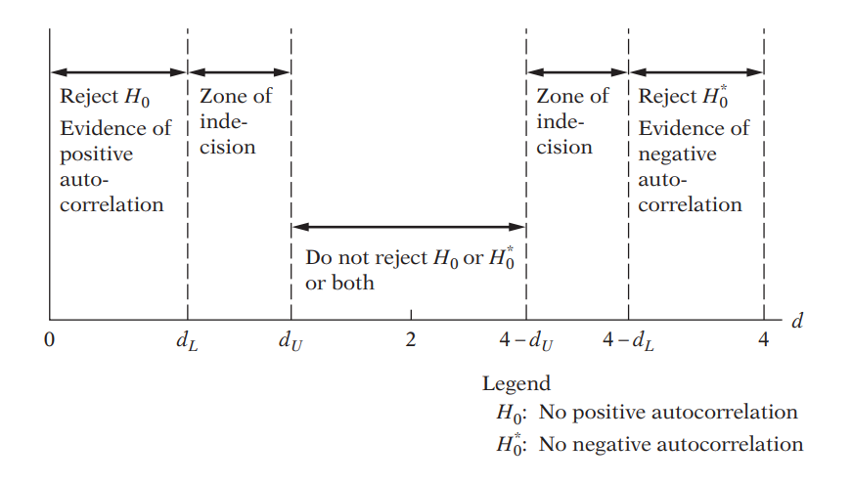
Since the Durbin-Watson d statistic is a function of $ρ$, the range of the test statistic is also dependent on the range of p. When,
- $ρ=0$ then d = 2
- $ρ=1$then d = 0
- $ρ=-1$then d = 4
Findings: In my case, d-statistics is 0.9212, which is close to 0. So, we can say that $u_{t}$ and $u_{t-1}$ has positive autocorrelation although this is not a strong positive autocorrelation where $ρ=1$.

A10. Breusch-Godfrey test

In BG test, hypothesis are as follows:
$$H_{0}: ρ_{1}=ρ_{2}={…=ρ}_{p}=0$$
$$H_{a}: any ρ≠0 , errors are correlated$$

Estimating the OLS and obtaining residuals

Here I am using 2 lags of orders to see the autocorrelation residuals and with its previous 2 lags

Moving Average equation looks as follows with 2 lags order:
$$ε_{t}= p_{1}ε_{t-1}+p_{2}ε_{t-2}+v_{t}$$

In Stata, the result looks as follows:

Findings: From the result, we can see both lags are statistically significant at 5% significance level and both has positive coefficient which means both lags influenced current lag positively.

Findings from the LM test: Here we can see NR2 > chi2 critical value, therefore we will reject the null hypothesis and can conclude that the model has autocorrelation
Same result can be obtained by Stata built in function by the following command after run the OLS regression,

Which also says the same thing that the chosen model has autocorrelation.

Multicollinearity test

A11. By looking at R-squared and t value to detect multicollinearity

Findings
In this regression model, R squared is not too high, 48.82%. If we look at t-statistics of the explanatory variables, we can see that all the t value is higher, where all of the variables are statistically significant at 95% confidence interval. In this case, we can say that there are no multicollinearity presents among the explanatory variables.

A12. Pair-wise correlations among regressors

In STATA, by the following command we can get pair wise correlation value of the variables.

Findings
From the results, we can see that none of the variables are highly pair wise correlated. Therefore, we can conclude that there isn’t enough pairwise correlation among regressors which can cause multicollinearity problem.

A13. Auxiliary regression for multicollinearity

Since multicollinearity arises because one or more of the regressors are exact or approximately linear combinations of the other regressors, one way of finding out which X variable is related to other X variables is to regress each X_{i} on the remaining X variables and compute the corresponding R², which we designate as R²_{i}.
So, first auxiliary regression, where bs is the dependent variable
Findings: If multicollinearity were presents, R square from the auxiliary regression would be very high but we can see it’s very low means that bs is not collinear with other independent variables

So, second auxiliary regression, where lenrol is the dependent variable
Findings: If multicollinearity were presents, R square from the auxiliary regression would be very high but we can see it’s very low means that bs is not collinear with other independent variables

Third auxiliary regression, where lunch is the dependent variable
Findings: If multicollinearity were presents, R square from the auxiliary regression would be very high but we can see it’s very low means that bs is not collinear with other independent variables

Fourth auxiliary regression, where lstaff is the dependent variable
Findings: If multicollinearity were presents, R square from the auxiliary regression would be very high but we can see it’s very low means that bs is not collinear with other independent variables

A14. Partial Correlations

In STATA, by the following command we can get partial correlation value of the variables

Findings: From the results, we can see that variables are very weekly partially correlated. But here none of the variables are highly partially correlated. Therefore, we can conclude that there isn’t enough partial correlation among regressors which can cause multicollinearity problem.

A15. Condition Index
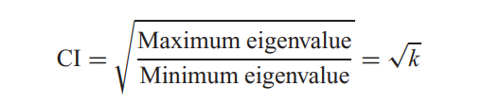
In STATA, by the following command, we can obtain the Eigenvalue and corresponding Conditional Index.
Rule of thumb: If k is between 100 and 1000 there is moderate to strong multicollinearity and if it exceeds 1000 there is severe multicollinearity. Alternatively, if the (CI = √k) is between 10 and 30, there is moderate to strong multicollinearity and if it exceeds 30 there is severe multicollinearity

Findings
From all of the observations from eigenvalue, Conditional Index and VIF, we can say that, multicollinearity doesn’t exist among the regressors.

